MTM: Notice of change in the seal sample
On 26 Dec 2016, Central Mining and Mineral Import - Export Joint Stock Company announced the change in the seal sample as follows:
- The seal sample:
Old Seal | New Seal
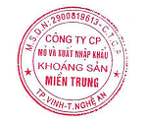 | 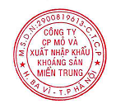

2. Number of the Company seal:
- Number of Company seal before the change: 1
- Number of Company seal after the change: 1
3. Effective date: 26 Dec 2016

